Connecting to the Student VPN

Contents

Before you try and connect - complete these three steps first. 1

To Access the Pre-shared key 2

Set up the VPN connection – Windows 10 and 11 2

Open Windows Powershell (type powershell into the search bar). 2

To Connect to the VPN 2

Set Up the VPN connection - MAC OS 3

In the network configuration create a new VPN connection. 3

Set Up the VPN connection Linux 4

In the network configuration create a new VPN connection. 5

Troubleshooting 6

# Before you try and connect - complete these three steps first.

1. **You must have Multi-Factor Authentication (MFA) set up on your student account with the default sign in method set to *Microsoft Authenticator*.** This means when you Launch a VPN session you will receive a notification to authenticate through the app via a notification. **Other authentication methods fail. Not doing this is the most common reason for failing to connect, If you are unsure see below.**

[*You can change your MFA preferences here.*](https://eur02.safelinks.protection.outlook.com/?url=https%3A%2F%2Fmyaccount.microsoft.com%2F&data=04%7C01%7CA.Gorbenko%40leedsbeckett.ac.uk%7Cd37be3d3d701431d315708d8fa8297b5%7Cd79a81124fbe417aa112cd0fb490d85c%7C0%7C0%7C637534786404966592%7CUnknown%7CTWFpbGZsb3d8eyJWIjoiMC4wLjAwMDAiLCJQIjoiV2luMzIiLCJBTiI6Ik1haWwiLCJXVCI6Mn0%3D%7C1000&sdata=YR9c7nzvmOGwrbIAvx5t0IlwxeuaLTXwlmKKT28F7SA%3D&reserved=0) *Under the ‘Security Info’ Tab change your MFA default method: to* ***Microsoft Authenticator – Notification***

1. **Student VPN access requires your username to be placed in the Active Directory group for the Student VPN. Your tutor can arrange this for you via the BEC helpdesk or may have already done so.**
2. **Finally you also need to have the VPN pre-shared key.**

## To Access the Pre-shared key

A Pre-shared key (PSK) is required to access the student VPN. This can be accessed [HERE](https://leedsbeckett.sharepoint.com/:w:/r/sites/ITS-EndUserGuides/_layouts/15/Doc.aspx?sourcedoc=%7B2B65FD60-9CD2-4729-B961-BC141BBC83E0%7D&file=Student%20VPN%20Guide.docx&action=default&mobileredirect=true&cid=10553cf7-2340-475b-ba89-bd01d463bffe). (if you have any issues, try it in an incognito window) To access the document, you **MUST** be logged into Office 365 using your **student account** (search Office 365 on Google). If you attempt with a personal account, you will encounter a form saying “you need permission to access this item” and will not be able to log in. Once you access the document, you will see a table containing the PSK **copy the key and save it** you will need it in the next steps.

# Set up the VPN connection – Windows 10 and 11

### Open Windows PowerShell (type PowerShell into the search bar).

Run both of the following commands separately, in PowerShell **making sure you replace the KEYHERE with the actual key you got above**, also keep the ' ' characters.

Add-VpnConnection -Name "LeedsBeckett VPN (MFA Stu)" -ServerAddress "buttercup.leedsbeckett.ac.uk" -DnsSuffix "leedsbeckett.ac.uk” -TunnelType "L2tp" -EncryptionLevel "Required" -AuthenticationMethod Eap -L2tpPsk 'KEYHERE' -Force -RememberCredential -PassThru

Set-VpnConnectionProxy -Name "LeedsBeckett VPN (MFA Stu)" -AutoConfigurationScript "http://wpad.leedsbeckett.ac.uk/wpad.dat" -PassThru

These two lines will create the VPN connection and then add the universities proxy service to that connection. This will mean when you are connected you will still be able to access the internet. Please note that in doing this all internet activity will be via the universities network.

Once complete you will find the VPN connection available in your network configuration.

# To Connect to the VPN

**Connect via Username and Password**

To connect to the VPN, press the Windows key and type ‘VPN settings’ Click the “MFA Stu” VPN and press connect. This will prompt you to enter your username and password.

**Approve your MFA request on your smartphone**

After you enter your credentials, you need to check your smartphone and approve a Microsoft Authenticator's request which would pop-up on the screen.

**Connection Success**

Once the connection has been successful, you should see yourself connected to the VPN in your WIFI options.

You are now connected to the Student VPN.

# **Set Up the VPN connection - MAC OS**

Please use the connection details provided above and the following screenshots to guide you through setting up the Student VPN on your MAC OS device

|  |  |
| --- | --- |
|  | In the network configuration create a new VPN connection. Give it a name and enter the server address |
|  |  |
|  | Copy and paste the PSK |
|  |  |
|  | Configure the following options |
|  |  |
|  | Click the proxies menu and enter the following in the URL field  <http://wpad.leedsbeckett.ac.uk/wpad.dat>  This will mean when you are connected you will still be able to access the internet. Please note that in doing this all internet activity will be via the universities network |
|  |  |

Once the connection is set up click on connect to connect.

# **Set Up the VPN connection Linux**

Please use the initial connection details provided above and the following screenshots to guide you through setting up the Student VPN on your Linux Device. The screenshots here are provide from a Ubuntu client and therefore may not directly relate to your variant of choice.

|  |  |
| --- | --- |
|  | In the network configuration create a new VPN connection. Give it a name and enter the server address |
|  |  |
|  | Click IpSec Settings and enter the PSK (as provided above) |
|  |  |
|  | Click PPP settings and configure the following options. |
|  |  |
| When connected to the VPN you will **not** have any internet connection by default. You may choose to edit your “network proxy” and enter the following configuration url.  <http://wpad.leedsbeckett.ac.uk/wpad.dat>  Note that most Linux variants do not natively provide a way to only have this in use when connected to the VPN. This is a **system wide setting.**  Therefore if you set this you **must** unset it again when disconnected from the VPN **or your home internet may not work**.  Whilst there are packages for linux which may support proxy settings only **whilst** connected to VPN, these are beyond the scope of this guidance. Troubleshooting | |

1. If you see the error message above, it means there was an issue with your authenticator. Most likely your default MFA method is not set to notification, or you may not have responded in time

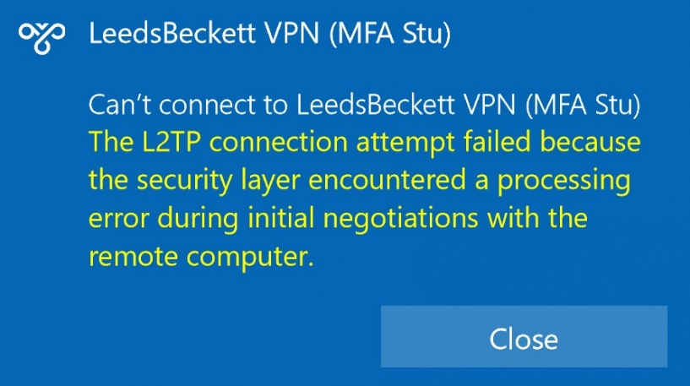

1. If you see the above error then most likely you have not entered the Pre-Shared Key into the PowerShell command, and the VPN is trying to use KEYHERE as the password. Go to VPN settings, delete the VPN, and start over.
2. Also, be aware that the VPN will not work if you are inside the university connected to Eduroam, so try a mobile hotspot (using mobile data NOT Eduroam).
3. It is very unlikely for the VPN to be down and any issues that arise are usually down to user error. If you encounter issues, delete the VPN and start setup for the beginning. If issues persist, please email [bectechsupport@leedsbeckett.ac.uk](mailto:bectechsupport@leedsbeckett.ac.uk) or visit JG212 for support.